Dated April 2017

THE COUNTY OF HEREFORDSHIRE DISTRICT COUNCIL

and

THE WORCESTERSHIRE COUNTY COUNCIL

and

THE MALVERN HILLS DISTRICT COUNCIL

and

THE GLOUCESTERSHIRE COUNTY COUNCIL

and

THE FOREST OF DEAN DISTRICT COUNCIL

A G R E E M E N T

as to the establishment and functions of the Malvern Hills Joint Advisory Committee

1

THIS AGREEMENT made the seventh day of April two thousand and seventeen

B E T W E E N the COUNTY OF HEREFORDSHIRE DISTRICT COUNCIL of the first part, the WORCESTERSHIRE COUNTY COUNCIL of the second part, the

GLOUCESTERSHIRE COUNTY COUNCIL of the third part, the MALVERN HILLS DISTRICT COUNCIL of the fourth part and the FOREST OF DEAN DISTRICT COUNCIL of the fifth part (hereinafter separately or collectively as the case may be referred to as "the Authority” or “the Authorities”)

WHEREAS the Malvern Hills Area of Outstanding Natural Beauty (Designation) Order 1959, designated as an Area of Outstanding Natural Beauty, an area of land comprising approximately 40 square miles situated in the Counties of Gloucestershire and Herefordshire and Worcestershire as shown on the plan appended to this Agreement (hereinafter referred to as “the Malvern Hills AONB”).

NOW IT IS HEREBY AGREED by and between the Authorities as follows:

- A Joint Advisory Committee to be known as the Malvern Hills AONB Joint Advisory Committee (hereinafter referred to as “the Committee”) shall be established for the purpose of advising and assisting the Authorities in carrying out their functions under Part IV of the Countryside and Rights of Way Act (2000) with respect to the Malvern Hills AONB in accordance with the provisions of Clause 2 of this Agreement.

- (a) It shall be the duty of the Committee to coordinate and facilitate the preparation, publication, implementation, monitoring and periodic review of the Management Plan for the Malvern Hills AONB.

  - Each of the Authorities shall consult with the Committee and, where appropriate, seek their advice (the Committee will respond within such period as is reasonable) in connection with any of the following:

Document1 2

- Matters in respect of which Byelaws should be made (Section 41 of the Countryside Act 1968 and also Section 90 of the National Parks and Access to the Countryside Act 1949) (hereinafter referred to as “the 1949 Act”);
- Subject to paragraph 2(d) below, the preparation or amendment of a development plan or planning policy document affecting all or part of, or likely to affect the setting of, the Malvern Hills AONB (Town and Country Planning Act

1990);

- Subject to paragraph 2(d) below, applications under the Town and Country Planning Acts, and consultations by statutory authorities, within, or likely to affect the landscape character or setting of, the Malvern Hills AONB.

  - Any general survey of access requirements within the Malvern Hills AONB, whether by making of access agreements or orders or by the acquisition of land for securing access by the public for open air recreation (Section 62(1) of the 1949 Act); and
  - The making of access agreements in the Malvern Hills and the making of access orders in the Malvern Hills (Section 64(5) and (6) of the 1949 Act and the Malvern Hills Act 1884);
- Consultations under paragraphs 2(b)(ii) and 2(b(iii) above shall be in accordance with the provisions of the ‘Proposed Scheme for Consultation on Planning and Development Issues between the Malvern Hills AONB Joint Advisory Committee and the Local Authorities of Worcestershire County Council, Malvern Hills District

Document1 3

Council, Herefordshire Council, Gloucestershire County Council

and the Forest of Dean District Council.’ as set out in Appendix 2 to

the Terms of Reference dated April 2017.

  - The Authorities shall make available such funds as are deemed by the Authorities to be necessary for the Committee to fulfil its functions [as defined above in paragraphs 2(a) and 2(b) above].
    - Provided that this shall not invalidate any action already taken by any Authority.
- The Committee shall consist of up to twenty members, ten members of which (hereinafter referred to as “the elected members”) shall be appointed as specified in Clause 5 hereof, and ten members of which (hereinafter referred to as “the nonelected members”) shall be persons nominated in the manner specified in Clause 6 hereof.
- The Authorities may also coopt further representatives of other relevant bodies to attend meetings in a nonvoting capacity for such period or periods as the Committee may from time to time determine.

- The elected members shall consist of:

  - two elected members appointed by Herefordshire Council;

  - two elected members appointed by Worcestershire County Council;

  - two elected members appointed by Malvern Hills District Council;,

  - one elected member appointed by the Forest of Dean District Council (also representing Gloucestershire County Council);
  - one elected member appointed by the Malvern Hills Trust;

  - two elected members, one appointed by the Herefordshire Parish Councils and one appointed by the Worcestershire Parish Councils,

Document1 4

from parishes the whole or any part of which is comprised within the Malvern Hills AONB. The member representing the Herefordshire Parishes shall also represent the Gloucestershire Parishes.

- The nonelected members shall consist of one representative each from/of:
  - Natural England;

  - the Forestry Commission;

  - Historic England;

  - the Herefordshire and Worcestershire Earth Heritage Trust

  - the Country Landowners and Business Association (with interests within the Malvern Hills AONB);
  - the Campaign for the Protection of Rural England;

  - local tourism interests;

  - local business interests;

  - National Farmers Union (with interests within the Malvern Hills AONB).
- Each elected member shall serve on the Committee for a term of two years but such member shall be eligible for reappointment to the Committee for a further term or further terms of two years should the appointing organisation(s) so resolve;
- Each nonelected member shall appoint a representative to serve on the Committee for a term of two years and such member may be reappointed to the Committee for such further term or terms of two years as the Committee may deem expedient.
- The Secretary (or some other appropriate administrative officer hereinafter referred to as “The Secretary”) of each organisation represented on the Committee shall forthwith, after the appointment of any member of the

Document1 5

Committee by that organisation, notify the name and address of the

member appointed to the Secretary of the Committee:

- An elected member who ceases to be a member of the organisation by which he/she was appointed shall upon such cessation also cease to be a member of the Committee;

- An elected member of the Committee may resign his/her membership by giving notice in writing thereof to the Secretary of the Committee and to the Secretary of the organisation by whom he/she was appointed;
- A nonelected member who ceases to be a member of the organisation by which he/she was appointed shall upon cessation also cease to be a member of the Committee;
- A nonelected member may resign his/her membership by giving notice in writing thereof to the Secretary to the Committee and to the appropriate officer of the body or organisation by whom he/she was nominated; and
- Upon a casual vacancy arising, the Secretary of the Committee shall forthwith notify, in the case of an elected member, the Secretary of the organisation by whom the member was appointed of the vacancy. Any such vacancy shall be filled as soon as practicable, in the case of an elected member, by the appointment of a new member of the organisation in whose representation the vacancy arises. In the case of the nonelected member, by the appointment by the, organisation of a new member. In each case, the person so appointed shall hold office during the remainder of the term of office of the person in whose place he/she is appointed.

Document1 6

- The meetings and proceedings of the Committee shall be conducted in accordance with the rules set out in the Schedule to this Agreement.

- The Committee shall be advised, in relation to their functions under this Agreement, by the appropriate officers of the Authorities jointly.
- Until such time as the Committee may decide to make other arrangements the Director of Corporate Services of Worcestershire County Council shall act as the Secretary of the Committee.
- This agreement may be terminated, or any part thereof may be varied, by agreement between the Authorities and any of the Authorities may give to the other six months’ previous notice, in writing, to terminate this Agreement.
- The Authorities shall be responsible for their own incidental costs.

15. This Agreement shall have effect as and from the seventh day of April,

two thousand and seventeen.

T H E S C H E D U L E

PROCEEDINGS OF THE JOINT ADVISORY COMMITTEE

- The meetings of the Committee shall be convened by the Secretary of the Committee and the said meeting shall be held at the Malvern Hills District Council Offices, Malvern in the County of Worcestershire or such other place or places as the Committee may direct.
- (a) The Committee shall in every year hold an annual meeting and such further meetings as may be necessary; and
  - the first meeting held after the annual meeting of the Authorities in any year, shall be the annual meeting of the Committee.
- (a) The Committee shall, at its annual meeting, elect from one of the elected or non-elected members a Chairman, who shall unless
he/she resigns or
Document1 7

ceases to be a member of the Committee, continue in office until

his/her successor becomes entitled to act as Chairman; and

  - The Committee may, at its annual meeting, appoint one of its number to be ViceChairman, who shall, unless he/she resigns or ceases to be a member of the Committee, continue in office until immediately after the election of the Chairman at the next annual meeting.
- On a casual vacancy occurring in the office of Chairman or ViceChairman (if appropriate) of the Committee, the vacancy shall be filled by the election or appointment by the Committee, of one of their number at its next meeting. The person so appointed shall hold office until the date upon which the person in whose place he/she is appointed would normally have retired.

- A substitute may be nominated to represent a member of the Committee in his/her absence provided that any substitute for an elected member shall also be a member of the organisation which that member represents.
CONDUCT OF MEETINGS

- (a) At a meeting of the Committee, the Chairman, if present, shall preside;

  - If the Chairman is absent from a meeting of the Committee the ViceChairman, if present, shall preside; and
  - If both the Chairman and the ViceChairman of the Committee are absent from the meeting of the Committee, such member of the Committee as the members present shall elect shall preside.

- (a) Subject to the provisions of paragraphs 7(b) and 8 below the Chairman of the Committee, or if the office of Chairman is vacant

Document1 8

the ViceChairman of the Committee, may call a meeting of the

Committee at any time;

- No less than ten working days at least before a meeting of the Committee a notice to attend the meeting specifying the business proposed to be transacted thereat and signed by the Secretary of the Committee shall be served upon each member of the Committee, and the Secretary shall also send a copy thereof to the Secretaries of the Authorities respectively, provided that:

  - want of service of the notice on any member of the Committee shall not affect the validity of the meeting;
    - excepting paragraphs (iii) and (iv) below, no business shall be transacted at any meeting called by either the Secretary or the Chairman of the Committee other than that specified in the notice of the meeting;
      - the Chairman, or in his absence, the ViceChairman, may, in consultation with the Secretary and with the agreement of the Committee, submit items requiring urgent consideration by the Committee; and
      - notwithstanding paragraph (iii) above, it shall be at the Chairman’s discretion to present the opportunity to members of the Committee to submit, in writing or orally, items of information, provided that these shall not be the subject of any debate.
      - notwithstanding paragraph (iii) above, it shall be at the Chairman’s discretion to present the opportunity to members of the Committee to submit, in writing or orally, items for discussion and decision, provided that details shall

Document1 9

have been notified to the Secretary at least one week prior

to the date of the meeting.

- No business shall be transacted at a meeting of the Committee unless at least three elected members are present thereat.
- Copies of the minutes of the proceedings at each meeting of the Committee shall be sent to the Secretaries of the Authorities, as soon as practicable, after the date of the meeting.
- (a) The mode of voting at meetings of the Committee shall be by show of hands, but on the requisition of any member of the Committee, supported by two other members who signify their support by rising in their places, the voting shall be recorded so as to show whether each member present and voting gave his/her vote for or against that question; and

  - the person presiding at a meeting of the Committee shall have a second or casting vote.
- All meetings of the Committee shall be open to the press and public and copies of agendas and background papers shall be made available for inspection unless:

  - the Committee decides otherwise in respect of a particular item;

  - the Authority to which the item relates has requested that it be treated as confidential.

Document1 10

IN WITNESS whereof the parties hereto have caused their Common Seals to be

hereunto affixed the day and year first above written

THE COMMON SEAL of the

COUNTY OF HEREFORDSHIRE DISTRICT COUNCIL ) is hereto affixed in the presence of: )

)

THE COMMON SEAL of the WORCESTERSHIRE )
COUNTY COUNCIL is hereto affixed in the )
presence of: )

THE COMMON SEAL of the GLOUCESTERSHIRE )
COUNTY COUNCIL is hereto affixed in the )
presence of: )

THE COMMON SEAL of the MALVERN HILLS )

DISTRICT COUNCIL is hereto affixed in the )
presence of: )

THE COMMON SEAL of the FOREST OF DEAN )

DISTRICT COUNCIL is hereto affixed in the )

presence of: )

Document1 11

Appendix 1 Map showing location and extent of the Malvern Hills AONB

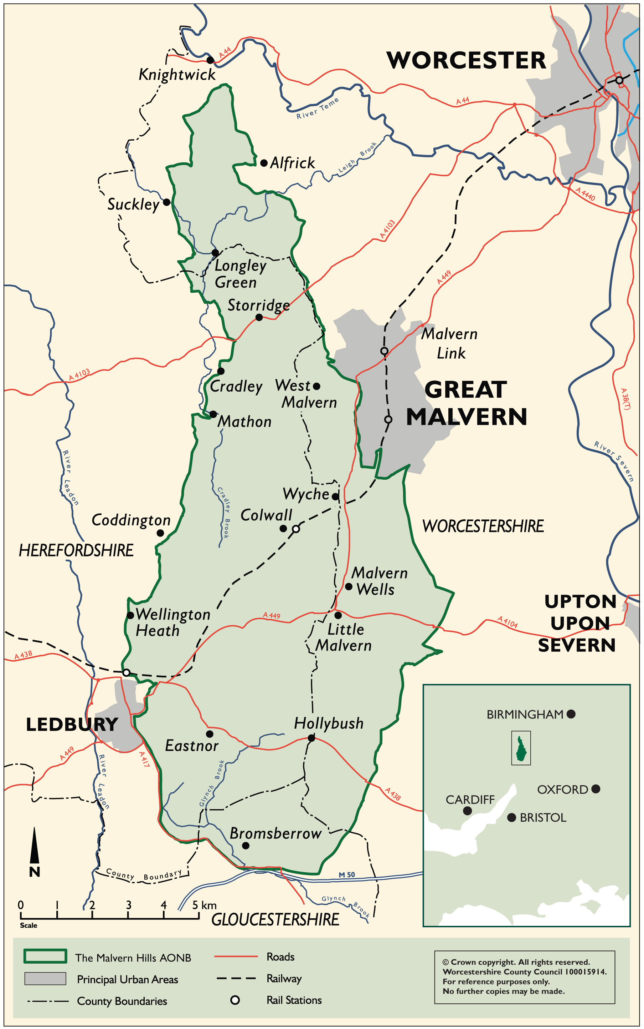

Document1 12

