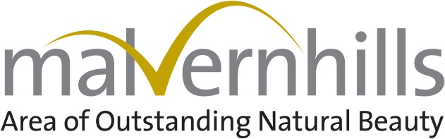
Community projects REF NUMBER:
Date received

Community Projects Fund 23/24
Application Form

If you need any help in completing this form please get in touch.
1. APPLICANT DETAILS
Name (main contact)
Position in organisation
Daytime telephone number
Email
Group or organisation name
Address of the person dealing with the application (including postcode):

Website address (if one is available)

2. ORGANISATION STATUS (Please tick and complete all boxes that apply)
Voluntary organisation | ☐
Parish Council | ☐
Charity | ☐ | Charity number:
Private Individual | ☐
Registered Company | ☐ | Company number:
Other | ☐ | Please define:
Do you have a formal constitution? | Yes  ☐ | No  ☐
Are you VAT registered? | Yes  ☐ | No  ☐ | Vat Number:

3. PROJECT DETAILS
Project title (a catchy name that describes your project)
Project description – please include:
- A brief outline of your project and what you would like to spend the grant on
- Tell us what your project aims to achieve
- Who are the key people/organisations involved?

How much funding are you asking for?
Will anyone else be funding this project?
Timetable for your project  (all projects should be able to make a final claim by Feb 1st 2024) |  | Start date (month/year):
 |  | Completion date (month/year):

- PROJECT LOCATION (complete 1 or 2)
- If the Project is located within the Malvern Hills AONB please state where: | - The project is outside the AONB but will benefit the following AONB parishes:
Who owns the land/building where the project will take place (if applicable)?
(Is there a lease? If so, how many years remain?) Have you obtained all the permissions you need? (e.g. planning permission, landowner’s consent, Local Authority or Environment Agency approval)

5. Please estimate the cost of your project, broken down into the following:
 | In Cash | In Kind  (See guidance) | Total
Paid for work – staff/contractors (please specify)  Volunteer time Spent on Project:  - donated/ in-kind time (including project management/admin) | £ | £ | £
Purchase of goods/ equipment | £ | £ | £
Other costs (please state what they are) | £ | £ | £
Total | £ | £ | £

- PROJECT CHECKLIST - MHAONB Management Plan priorities
Your application will score more if it helps to deliver our vision for the Malvern Hills AONB
Please only complete the boxes below that apply to your project

WILL YOUR PROJECT? | HOW?
- Help the AONB to become a place of rich, diverse and abundant wildlife?

- Help people to enjoy, value and care for the AONB? We

- Maintain the distinctive character and natural beauty of the AONB?

7. DIRECT & COUNTABLE RESULTS - outputs of your project:
How many and what type of people, businesses, community groups, etc. will benefit from your project
Estimated number of volunteers involved with the project and volunteer days spent on the project
Countable achievements, e.g. trees planted, nest-boxes put up, training sessions completed etc
Other direct or countable results arising from your project
Who will look after the completed project and how will this be funded in the future?

8. COMMUNITY PROJECTS FUND CRITERIA
The aim of the fund is to promote and enhance the environmental, economic and social wellbeing of the AONB. Please tick any of the criteria below that your project meets.
Environmental criteria – does the project? |  | Economic criteria – does the project?
☐ | Conserve and improve the built and/or natural environment | ☐ | Meet local economic needs
☐ | Protect or increase biodiversity | ☐ | Provide long-term economic benefit to the community
☐ | Promote or apply ‘reduce; re-use; recycle’ principles | ☐ | Make a contribution to local training and/or employment prospects
☐ | Promote the use and/or generation of renewable energy | ☐ | Make use of local suppliers of products, services and materials
☐ | Reduce the need for car, van and lorry journeys or promote walking and cycling | ☐ | Demonstrate responsible business practices or promote community support for the local economy
☐ | Minimise pollution of the land, air and water
Social criteria – does the project? |  | Criteria for success – does the project?
☐ | Help people feel part of their community and support them to take action | ☐ | Encourage greater awareness and understanding of sustainability – living today in a way that doesn’t harm the future
☐ | Conserve and support our cultural heritage | ☐ | Promote understanding and enjoyment of the AONB’s special qualities
☐ | Encourage links between urban groups and those who live and work in the AONB | ☐ | Have a clearly defined set of realistic aims and measurable outcomes (changes or results)
☐ | Combat social exclusion, particularly of young people | ☐ | Have someone to manage it, so that it will achieve its aims and measure its outcomes
☐ | Help combat loneliness | ☐ | Demonstrate innovation, creativity or best practice
☐ | Encourage people to have a more sustainable lifestyle | ☐ | Bring organisations together in partnership to tackle an identified need
☐ | Encourage those who might not access the AONB to visit and enjoy it | ☐ | Add value or a new dimension to existing sustainability projects
 |  | ☐ | Explore opportunities to access funds and/or support in kind from other sources

- DECLARATION
I certify that all the information provided in this application is true to the best of my knowledge. I understand that any misleading statements, whether deliberate or accidental, could make the application invalid and therefore liable for the return of any money.

Signature:

Printed name: Date:

Please return the completed application form to: khumphries@worcestershire.gov.uk

The Malvern Hills AONB Community Projects Fund is delivered locally by the Malvern Hills AONB team and funded by Defra.
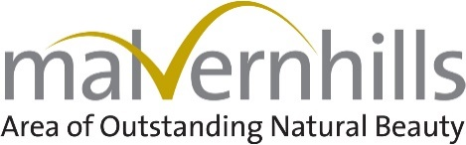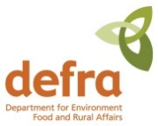

V6 May 23

